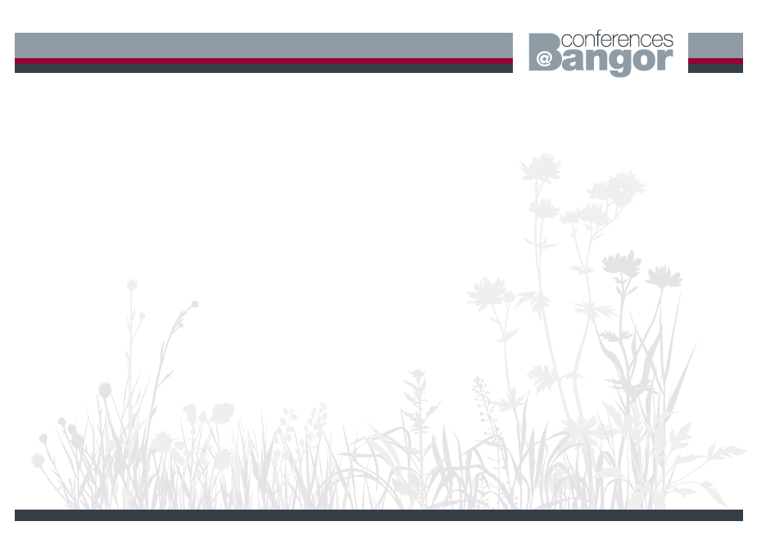
CONFERENCE SERVICES ACCOMMODATION FORM
COMMUNITY STABILITY & COHESION HISTORICAL & CONTEMPORARY CONFERENCE – BANGOR UNIVERSITY
13th September – 14th September 2012

Please complete and return the booking form to: Karen Evans, Conference Services, Idwal Building, Bangor University, Ffriddoedd Road, Bangor, Gwynedd LL57 2GP.
Tel: (01248) 38 3577 Fax: (01248) 38 8822 Email: K.evans@bangor.ac.uk

ACCOMMODATION BOOKINGS MUST BE PAID FOR IN ADVANCE. PLEASE PRINT CLEARLY
Title: First Name: Surname:
Address (for your confirmation & receipt):
Daytime Telephone:
Email address (Please print clearly):

Accommodation is a single en-suite bedroom which is available from 2pm on your day of arrival and must be vacated by 9.30am on your day of departure.
Please tick  each option required and input the total payable.
Terms and Conditions
Cancellations received more than 24 hours prior to the arrival date, all fees will be refunded less £15.00 admin fee.
Cancellations received within 24 hours prior to arrival or a non arrival will be charged one nights’ accommodation. Substitutes will be accepted but they will be charged an admin fee of £5.00.
Refunds will take 21 days to process.
Accommodation bookings close on 7th September 2012 DateTuesday
11th September Wednesday
12th SeptemberThursday
13th SeptemberFriday
14th SeptemberTOTALBed & Breakfast
£31.00

£31.00

£31.00
£31.00TOTAL enclosed / to be debitedPayment Details
Cheque: I enclose a cheque for £……….. made payable to “Bangor University”
Card: Please debit my credit/debit card: Type of card (Amex not accepted) Visa  Mastercard   Switch   

Expiry Date ___/___ Switch: Issue No ___ Valid From ___/___
Card Number: Switch Only

Additional Information:
Signed.......................................................Date:........................................

